**PAN ANALYTICAL**

**X’PERT POWDER XRD**

**THIN FILM OPERATING MANUAL**

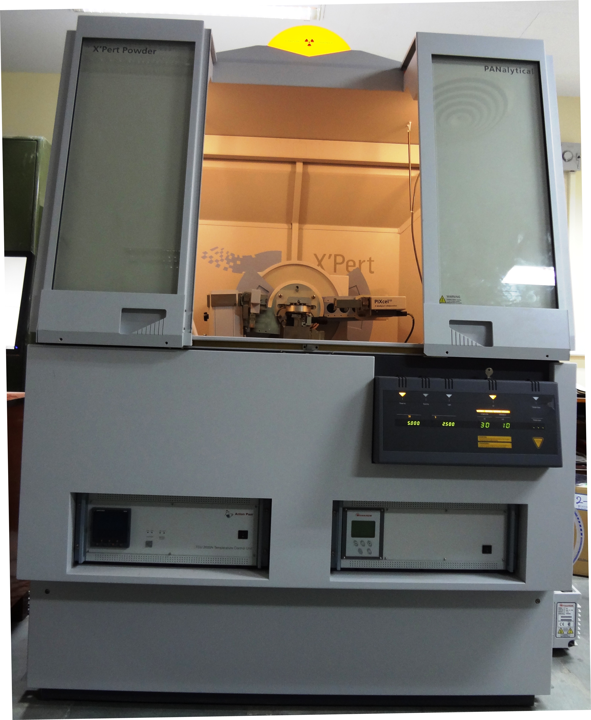

**Advanced Centre for Materials Science**

**IIT Kanpur**

**Facility Convener Instrument Expert**

**Dr. Nilesh Prakash Gurao Mr. Ravi Srivastav**

**Assistant Professor MSE Department, IIT Kanpur**

**MSE Department, IIT Kanpur**

Operating

**Operating procedure for thin film mode**

1. Install thin film optics on the i.e. parabolic mirror on the incident beam side, collimator on the diffracted beam side.
2. Power ON XRD Machine MCB (on backside wall of the XRD machine)
3. Power ON diffractometer (press the button o the XRD Panel)
4. Power ON Chiller MCB
5. Turn the Key (on Diffractometer) quarter clockwise. (wait for few minutes to initialise the machine, default voltage and current values 30kV and 10mA will appear)
6. Open Data collector software on the computer. Following window will appear





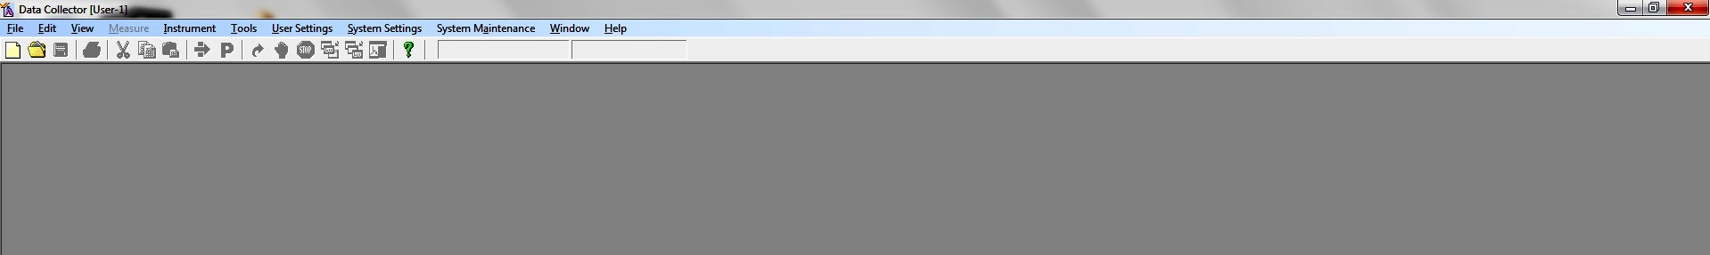

1. Go to Instrument and connect.

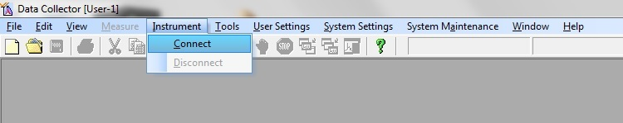

1. Following message will appear click on OK.

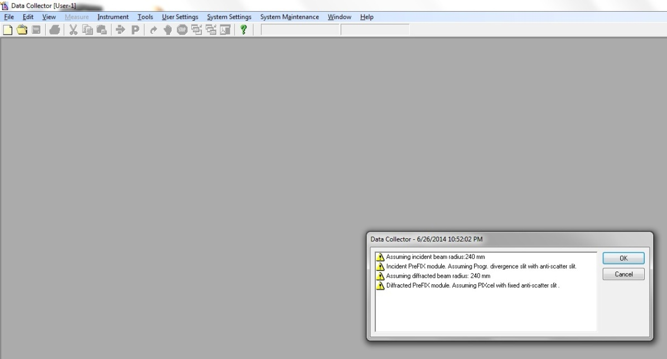

1. Following window will appear

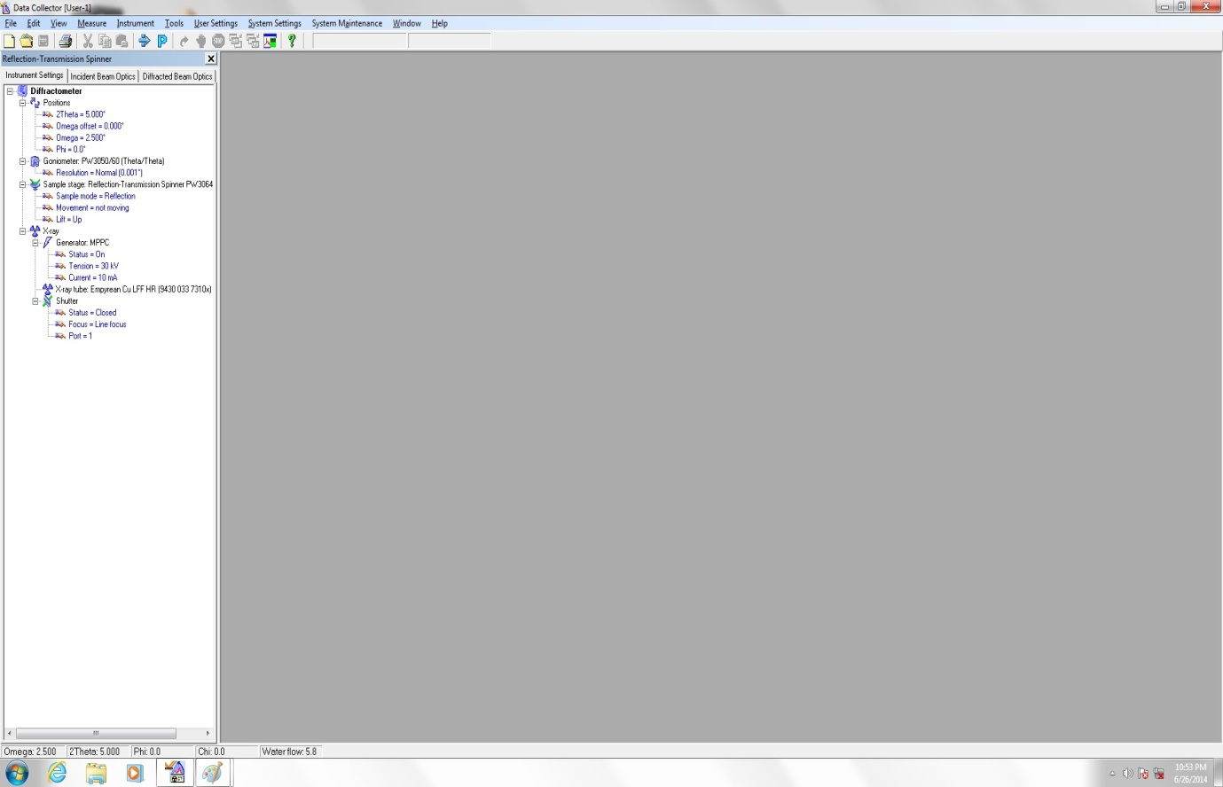



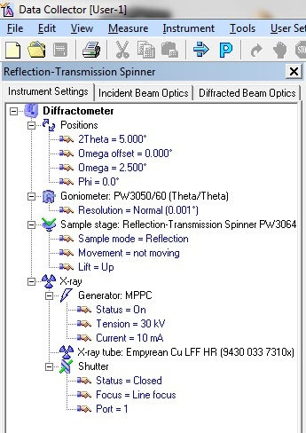

1. Go to Incident beam optics and double click on incident beam path following window will appear

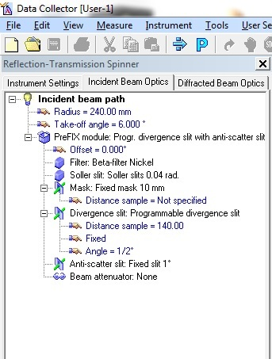

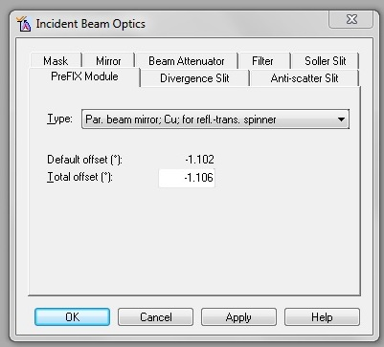

1. Select the following parameters
   1. Prefix mode: Parabolic beam mirror Cu for refl.-trans spinner



* 1. Divergence slit: 1/16”
  2. Beam Attenuator: beam attenuator mirror Cu 0.2mm/Ni 0.2mm
  3. Attenuator Factor: 1.00
  4. Usage: Do not Switch

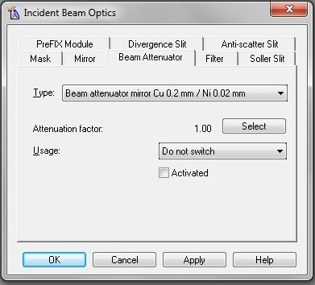

* 1. Mask: None
  2. Filter: None
  3. Solar Slit: None
  4. Antiscatter Slit: None
  5. Press Apply then OK.

1. Go to Diffracted beam optics and double click on diffracted beam path1 following window will appear

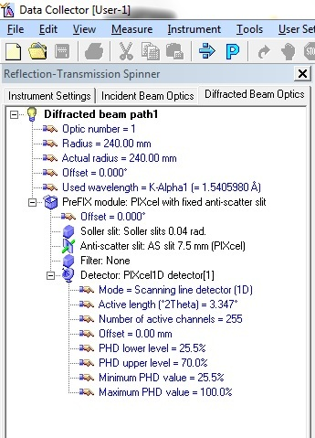

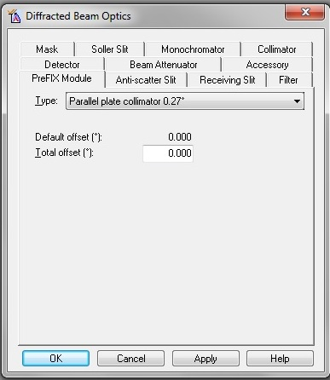

1. Select the following parameters
   1. PreFIX Module: Parallel plate collimator 0.27”
   2. Detector Type: PIXcel 1D Detector[1]
   3. Receiving Slit: 0D
   4. Active length: 14.025
   5. Active channels:255
   6. Used wavelength = K-Alpha1

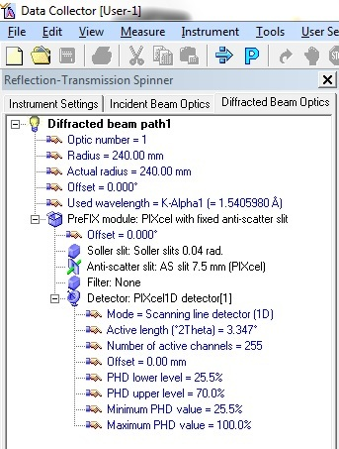

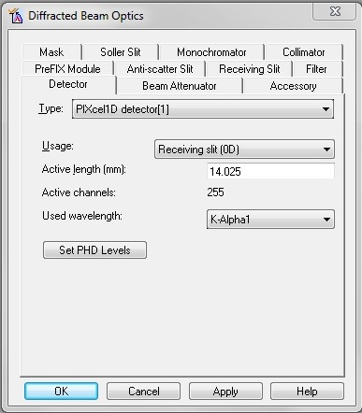

* 1. All other options: None
  2. Press Apply then OK.

1. Go to user setting and select sample offset

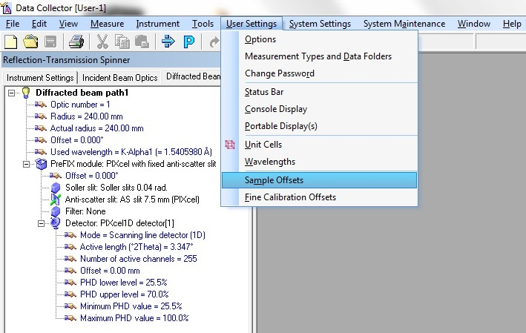

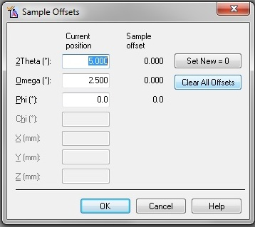

* 1. Clear all offset
  2. Press OK

1. Go to instrument setting double click on position following window will appear

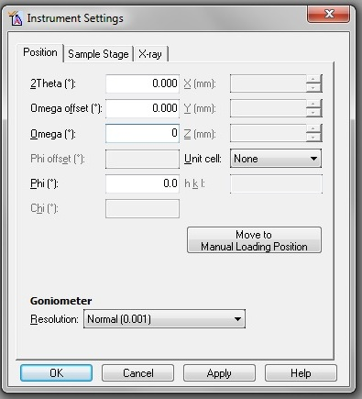

1. Make the following entries
   1. 2theta: 0
   2. Omega: 0
   3. Omega offset: 0
   4. Phi: 0
   5. Press Apply then OK.
2. Go to Manual Scan following window will appear.

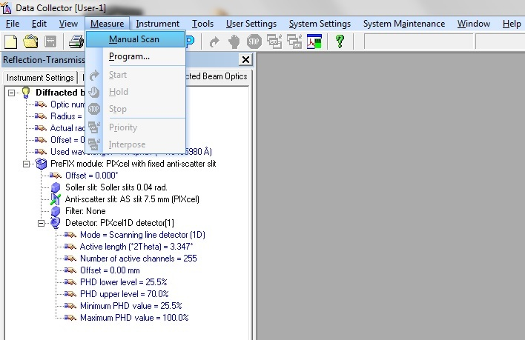

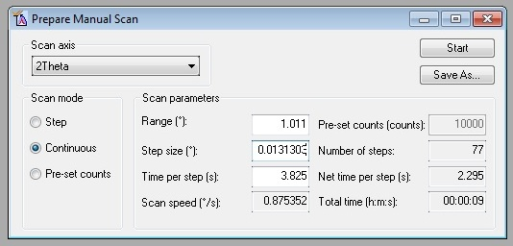

1. Select the following parameters
   1. Scan Axis : 2 theta
   2. Range : 1°
   3. Time per step : 1
   4. DO NOT DISTURB OTHER PARAMETERS
2. Press Start
3. Peak will appear.
   1. Right click on the Peak
   2. Go to peak mode
   3. Click on MOVE To then Close
4. Go to user setting and click fine calibration offsets following window will appear

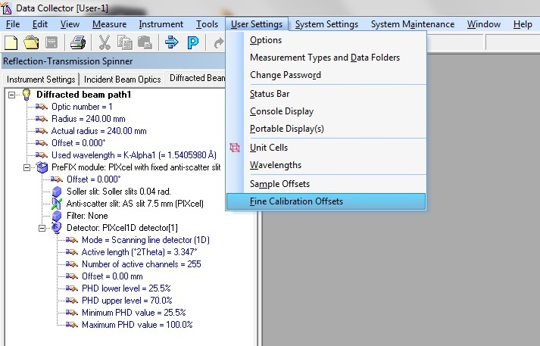

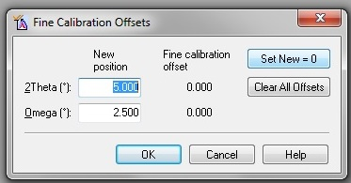

* 1. Set New = 0
  2. Press OK

1. Click on Shutter to close shutter

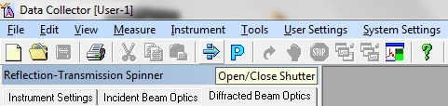

**\*\* After manual scan OFF the Shutter by pressing on the icon. \*\***

1. Remove the Beam Attenuator Cu 0.2mm/Ni 0.2mm and insert the mask i.e. 10mm or 20mm (according to your requirement).
2. Change the divergence slit from 1/16” to 1/8” or 1/4" or 1/2" etc. (according to your requirement).
3. Double click on sample stage reflection and select sample stage.

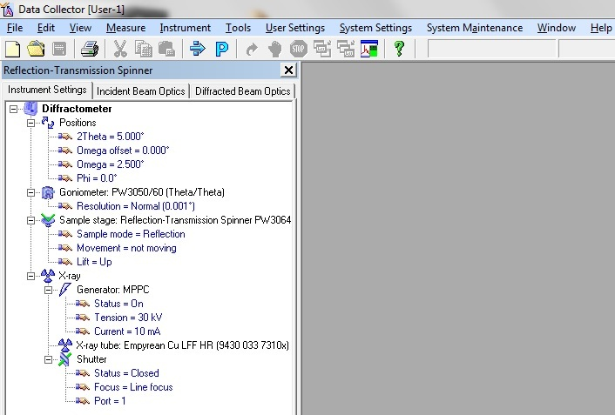

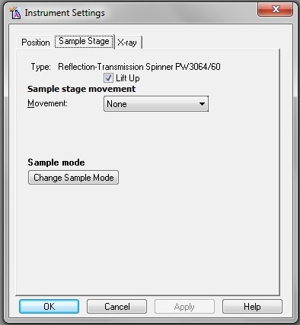

* 1. Untick Lift Up
  2. Mount the sample
  3. Tick Lift Up
  4. Click on Apply then OK.

1. Go to Program and Select New Program following window will appear

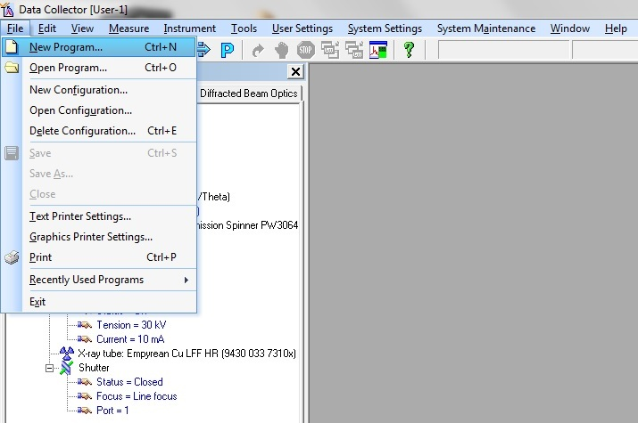

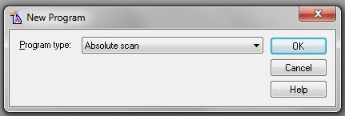

* 1. Select Absolute Scan and press OK following window will appear.

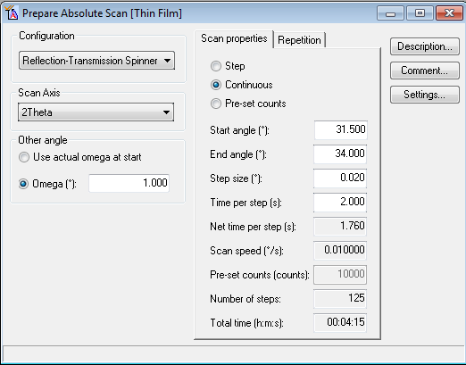

* 1. Select Scan Axis: 2 theta
  2. Define the measurement parameter i.e. omega (grazing angle), Start angle, End angle and Time per step required for your sample.

1. Click on setting the following window will appear.



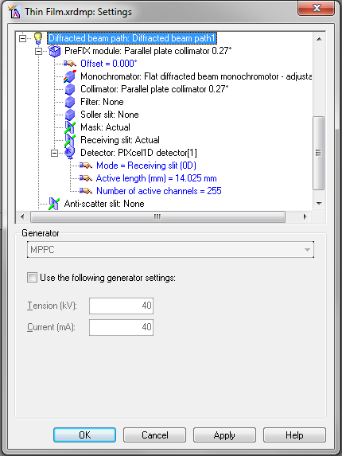

1. Go into Incident beam path and select the following
   1. PreFIX Module: Par beam mirror; Cu; for refl-trans. Spinner
   2. Mirror: Parallel beam X-ray mirror for Cu-radiation
   3. Divergence slit: Fixed slit 1/2", 1/4", 1/8”, 1/16” which is used in the machine.
   4. Filter: None
   5. Soller Slit: None
   6. Beam Attenuator: None
   7. Mask: select 10mm, 20mm which is used in the machine.
   8. Anti-scatter slit: None
2. Go to Diffracted beam path: Diffracted beam path1 and select following
   1. PreFIX module: Parallel Plate collimator 0.27”
   2. Monochromator:None
   3. Collimator: Parallel plate collimator 0.27”
   4. Filter:None
   5. Soller Slit: None
   6. Mask:None
   7. Receiving slit:None
   8. Detector:PIXcel1D Detector[1]
      1. Mode: Receiving slit [(0D)]
      2. Active length (mm) = 14.025mm
      3. Number of Active channels = 255
   9. Antiscatter slit: None
   10. Beam Attenuator: None
3. Save the Program
4. Go to Measure and click on Program the following window will appear

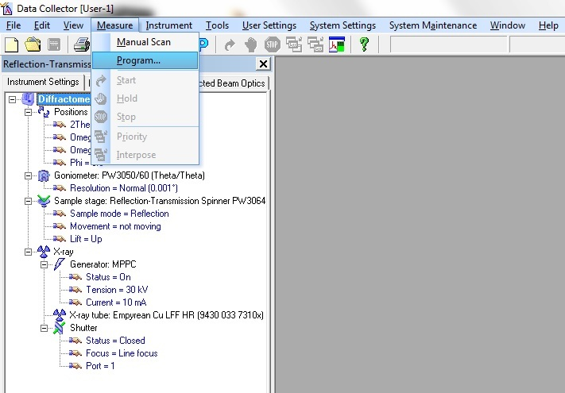

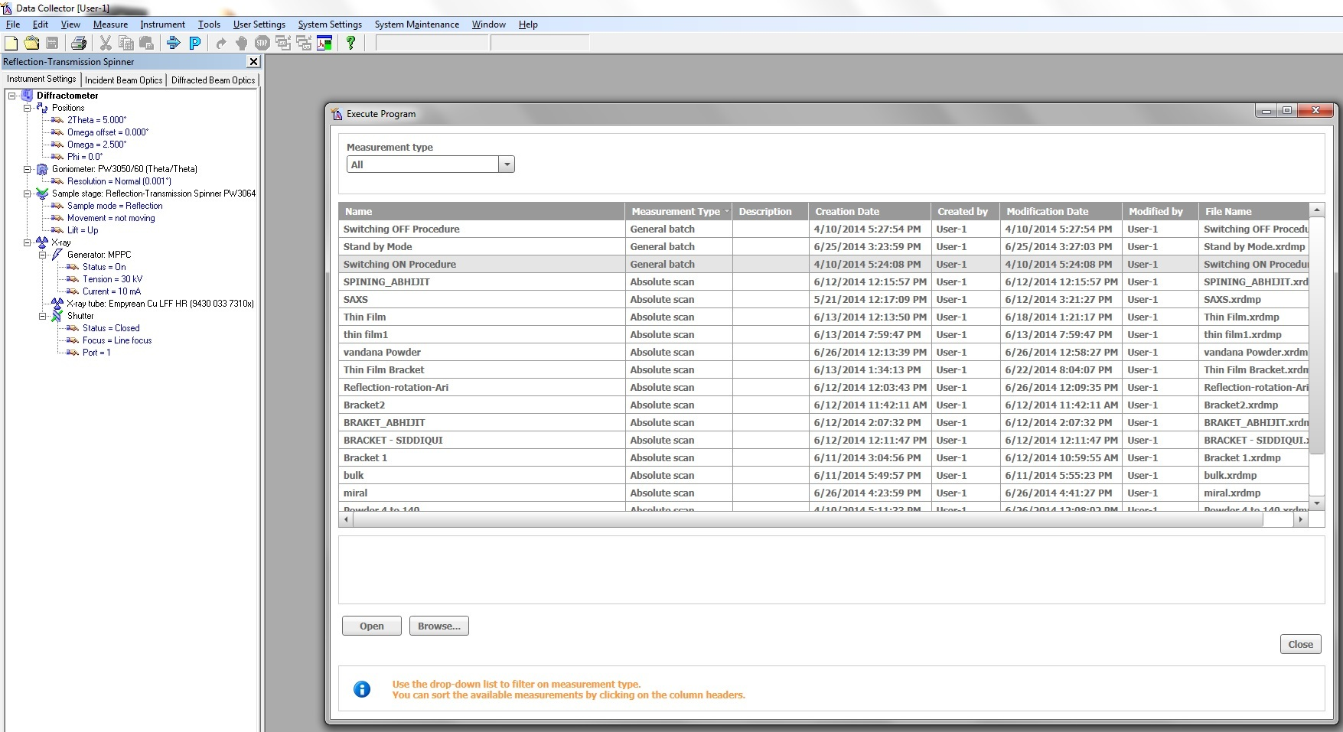

* 1. Select Switching ON Procedure (to increase voltage to 45kV and current to 40 mA)
  2. Click on Open
  3. Start then OK

1. Again go to Measure click on Program
   1. Select your specified Program
   2. Click on Open
   3. Give the location to the scanned file.
2. Scan will start and will be saved automatically to your mentioned destination.
3. After scan go to Measure click on Program
   1. Select switching OFF Procedure (to decrease the voltage and current to 0kV and 0mA)
   2. Click to Open
4. Go to Instrument select Disconnect.

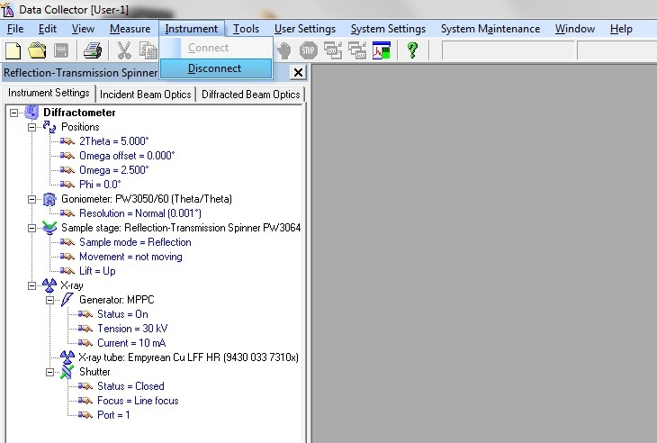

1. Close the Data Collector software.
2. Press Standby button on Diffractometer.
3. Move the key quarter Anticlock wise.
4. Switch OFF the MCB (on the backside wall of the Machine)
5. Switch OFF the Chiller MCB.
6. Switch OFF the Computer.
7. Make the Entry in the Register.